Project Report

By Varun Kumar

**Date:** 07 July 2025

**Result Analysis Of**

**2nd Semester**

**Table of Contents**

1️. Introduction  
2️. Data Collection & Dataset Structure  
3️. Analysis Performed with Visualizations  
4. Credit-Weighted Percentage Calculation  
5. Observations & Inference

6. Conclusion

**Introduction**

This project is a simple and personal attempt to analyze the 2nd semester results of my own friend group in B.Tech CSE (Batch 2025). Since we often discuss our marks and how we performed in different subjects, I thought it would be interesting to collect everyone’s marks and see what patterns or trends we could find when we actually put the numbers together.

The main idea was to understand things like:

* Which subjects we scored best and worst in.
* Who topped in which subject.
* How our internal and external marks compared.
* Who got the highest and lowest SGPA.
* And how our official percentages would look if calculated based on subject credits.

To do this, I used basic Python tools like **Pandas**, **Matplotlib**, and **Seaborn** to handle the data and make some simple graphs. Even though the group is small (only 5 of us), it was a fun way to see our academic performance from a different perspective — not just numbers on a mark sheet but actual trends and comparisons.

In the end, this small project helped me learn how data analysis can be useful, even with a small dataset, and how easy it is to find interesting patterns in everyday things like exam results.

**Data Collection & Dataset Structure**

The data for this analysis was collected manually from the official **IPU Rank List portal**, where detailed result information for each student is published. I individually accessed the mark sheets of my 5-member friend group from this portal and carefully recorded their marks for each subject.

**How the Dataset Was Created:**

A **CSV file** was created to store the collected data in a structured format. For every student, the following details were noted:

* **Total Marks (Internal + External)** for each of the 12 subjects.
* **SGPA (Semester Grade Point Average)**
* **Official Percentage** (as provided by the university)
* **Group Rank**, based on SGPA

**Dataset Structure:**

The dataset consists of the following fields:

* **Name**
* **AC_TOTAL, AM-2_TOTAL, ES_TOTAL, etc.** — total marks in each subject.
* **SGPA**
* **Official Percentage**
* **Rank (within the group)**

**Sample Data Table:**

|  |  |  |  |  |  |  |  |
| --- | --- | --- | --- | --- | --- | --- | --- |
| **Name** | **AC_TOTAL** | **AM-2_TOTAL** | **…** | | **SGPA** | **Percentage** | **Rank** |
| Varun | 86 | 77 | | … | 9.20 | 85.83 | 14 |

Even though the dataset includes only 5 students, it was sufficient for performing meaningful analysis and identifying trends within a small academic group.

**Analysis Performed**

Once the data was collected and organized, several types of analyses were performed to better understand the academic performance of the group. The aim was to identify trends, compare subject-wise performances, and evaluate overall results using simple data analysis techniques.

The following analyses were carried out:

**1. Subject-wise Topper and Lowest Scorer:**  
For each subject, the highest and lowest scorers were identified based on total marks. This helped to see which subjects were the strongest or most challenging for different students.

1. **Applied Chemistry Marks Distribution:**

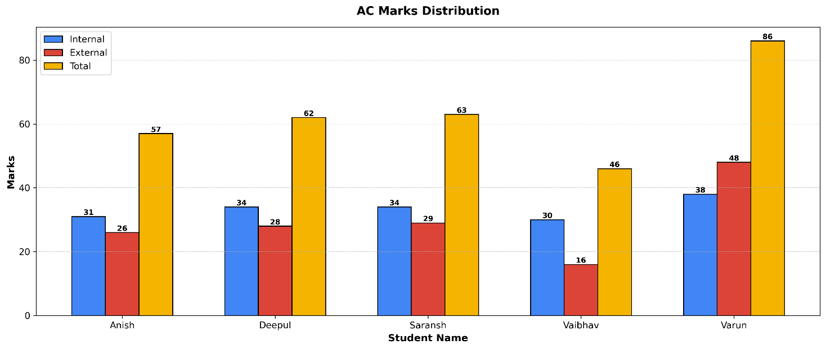

🏆 Topper(s): **Varun** with 86 marks

❌ Lowest scorer(s**): Vaibhav** with 46 marks

**(b) Applied Physics – II Marks Distribution:**

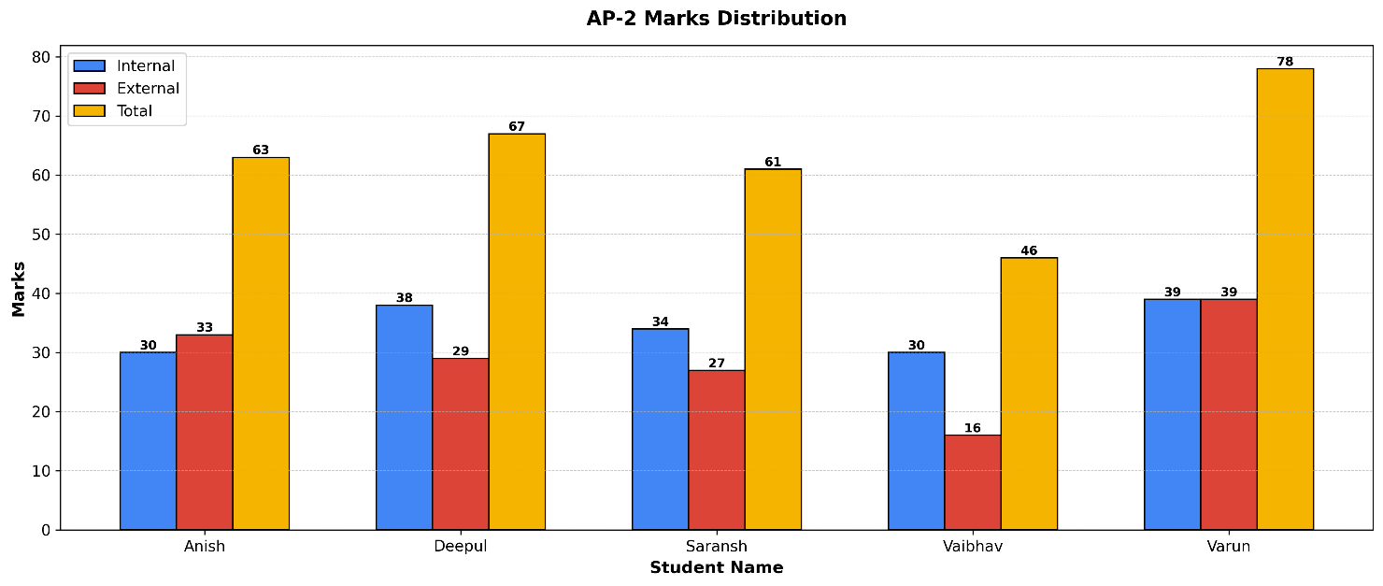

**🏆 Topper(s): Varun with 78 marks**

**❌ Lowest scorer(s): Vaibhav with 46 marks**

1. **Applied Mathematics-2 Marks Distribution:**

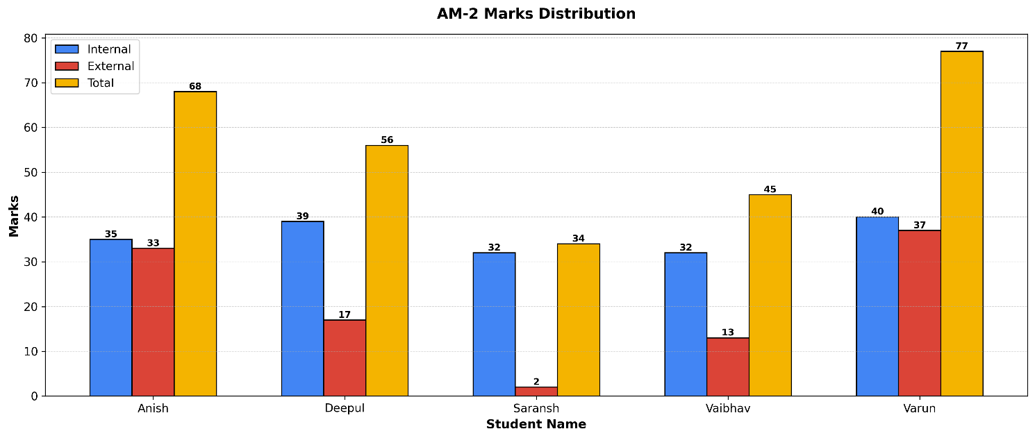

**🏆 Topper(s): Varun with 77 marks**

**❌ Lowest scorer(s): Saransh with 34 marks**

1. **Electrical Science Marks Distribution:**

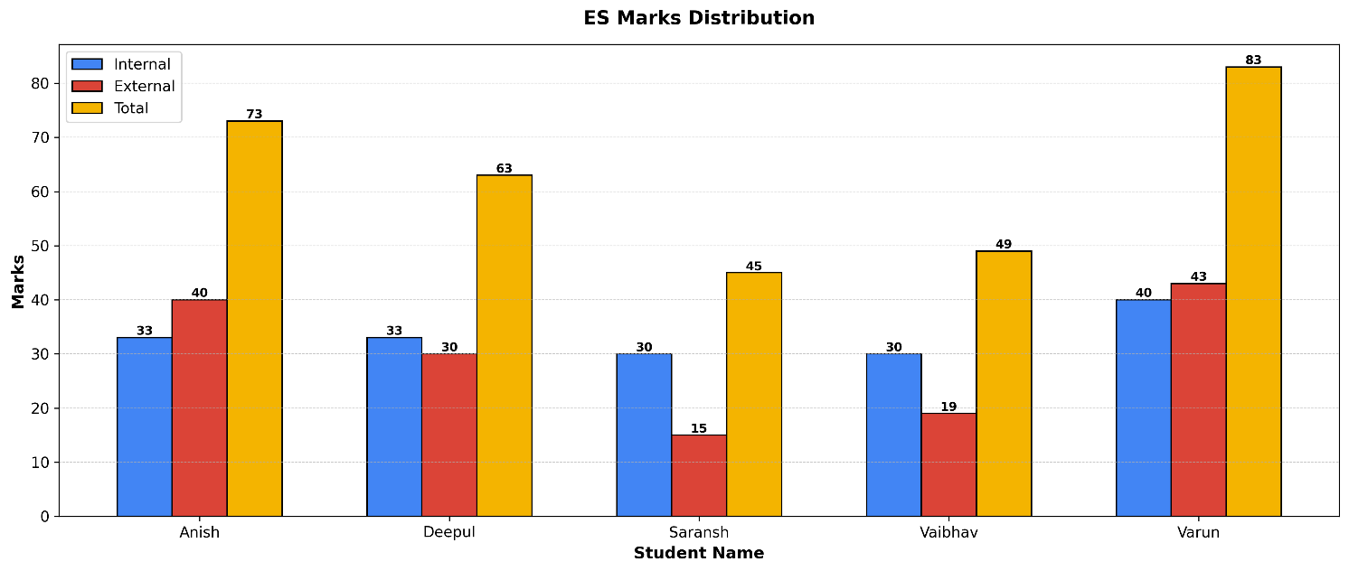

**🏆 Topper(s): Varun with 83 marks**

**❌ Lowest scorer(s): Saransh with 45 marks**

1. **Engineering Mechanics Marks Distribution:**

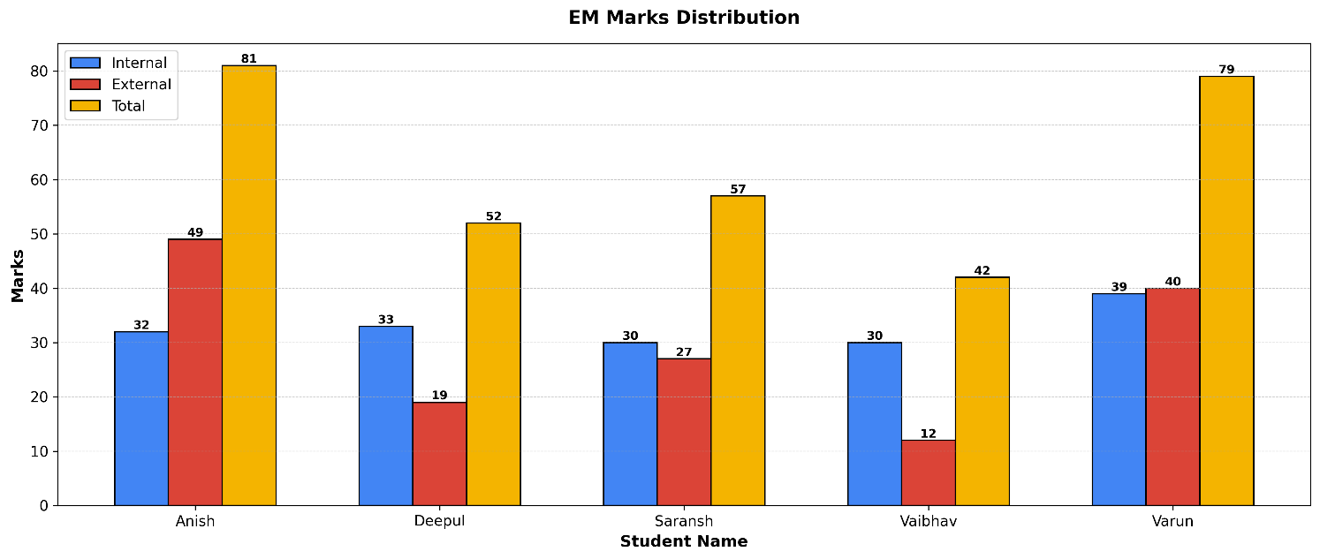

**🏆 Topper(s): Anish with 81 marks**

**❌ Lowest scorer(s): Vaibhav with 42 marks**

1. **Indian Constitution Marks Distribution:**

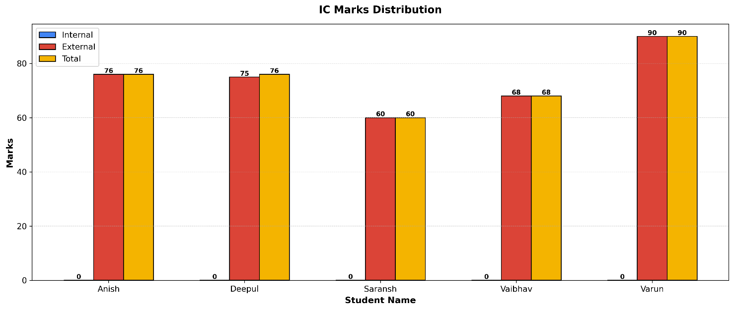

**🏆 Topper(s): Varun with 90 marks**

**❌ Lowest scorer(s): Saransh with 60 marks**

1. **Human Values And Ethics Marks Distribution:**

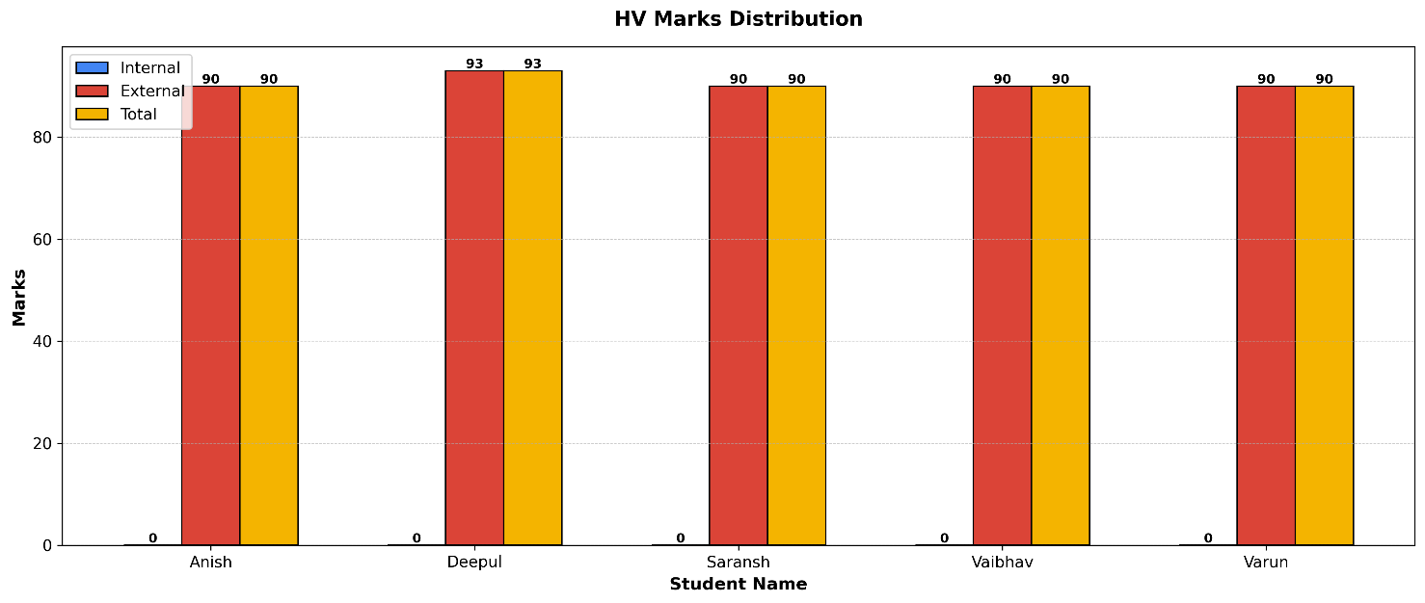

**🏆 Topper(s): Deepul with 93 marks**

**❌ Lowest scorer(s): Anish, Saransh, Vaibhav, Varun with 90 marks**

1. **Applied Chemistry Lab Marks Distribution:**

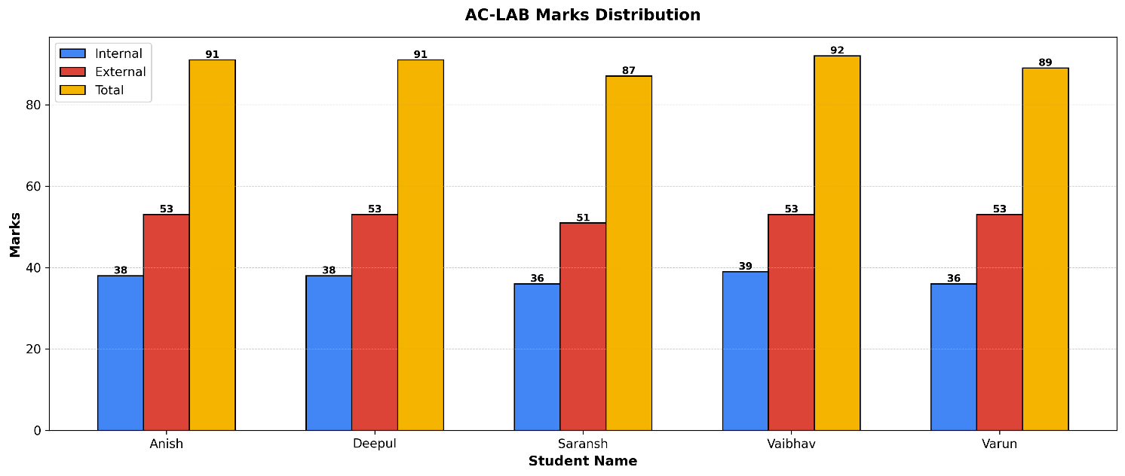

**🏆 Topper(s): Vaibhav with 92 marks**

**❌ Lowest scorer(s): Saransh with 87 marks**

1. **Applied Physics – II Lab Marks Distribution:**

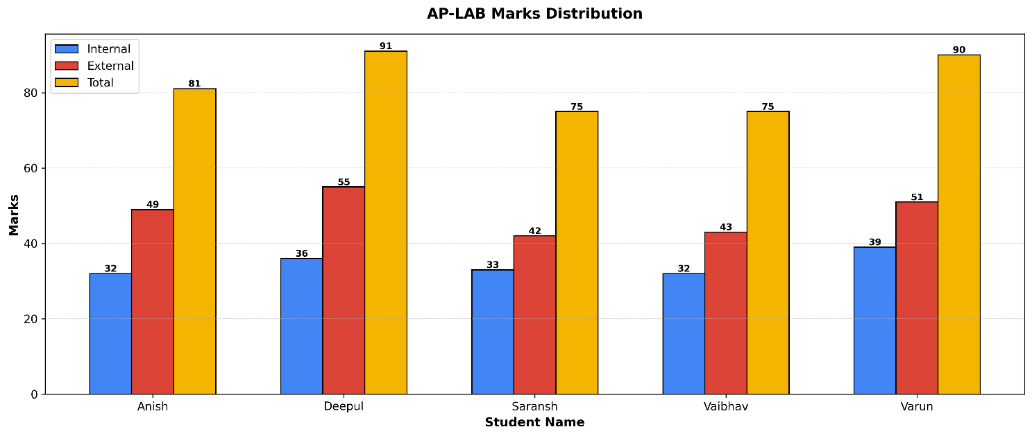

**🏆 Topper(s): Deepul with 91 marks**

**❌ Lowest scorer(s): Saransh, Vaibhav with 75 marks**

1. **Electrical Science Lab Marks Distribution:**

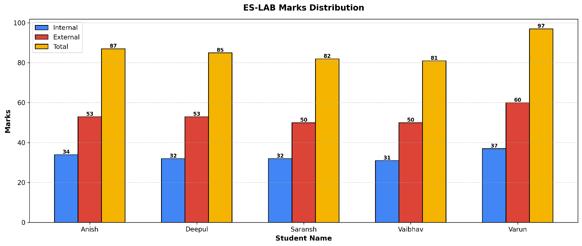

**🏆 Topper(s): Varun with 97 marks**

**❌ Lowest scorer(s): Vaibhav with 81 marks**

1. **Engineering Graphics Lab Marks Distribution:**

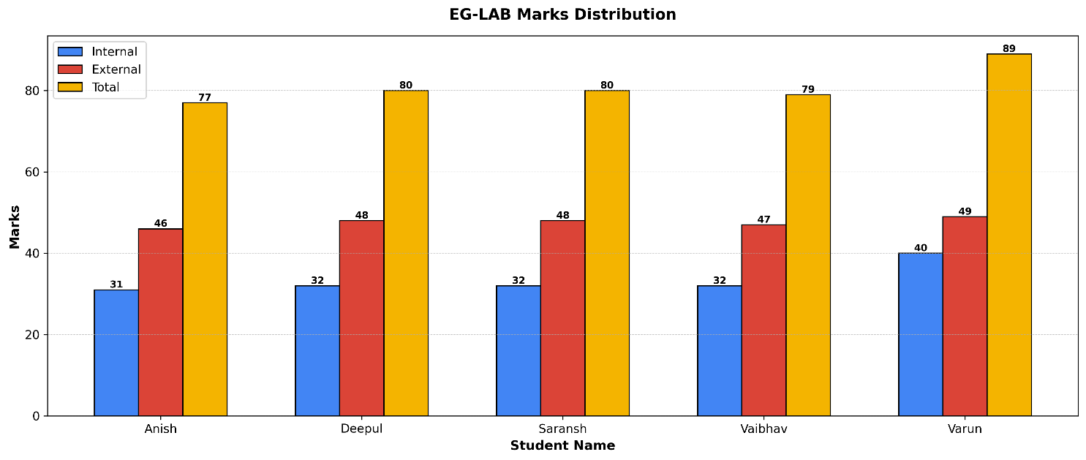

**🏆 Topper(s): Varun with 89 marks**

**❌ Lowest scorer(s): Anish with 77 marks**

1. **Workshop Marks Distribution:**

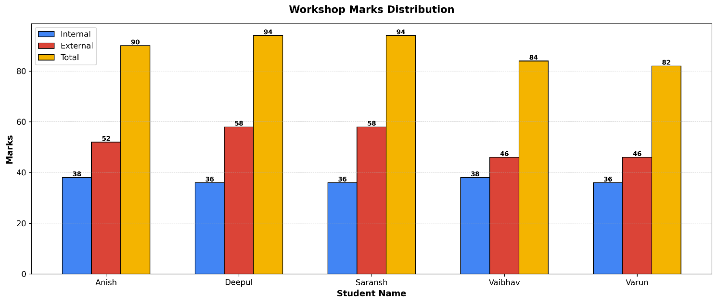

**🏆 Topper(s): Deepul, Saransh with 94 marks**

**❌ Lowest scorer(s): Varun with 82 marks**

**Observation:**  
From the graphs, it’s clear that **Varun** consistently topped in most theory subjects, while **Deepul** performed strongly in workshop and lab subjects. **Vaibhav** and **Saransh** appeared more frequently in the lowest scorer list, especially in theory papers.

**2. SGPA Analysis:**  
The students with the highest and lowest **SGPA** in the group were identified to compare overall semester performance.

**Input:**

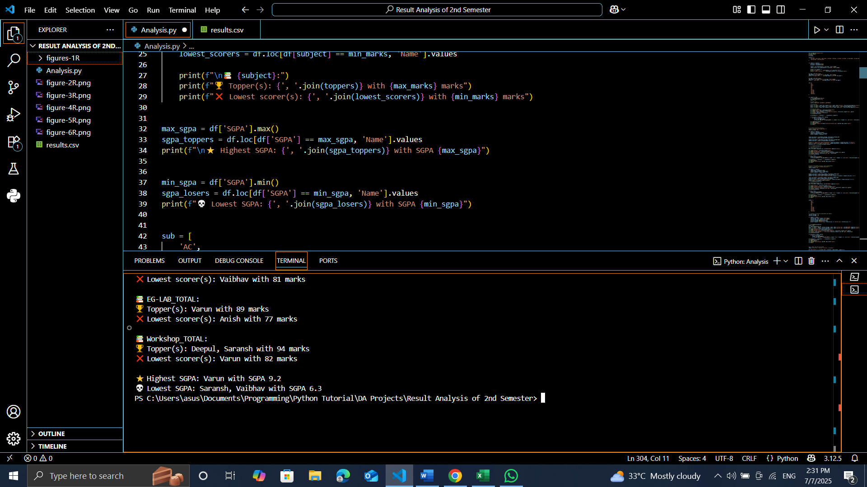

**Output:**



**3. Subject-wise Average Marks:**  
The average total marks for each subject were calculated to find out which subjects had higher or lower overall group performance.

**Visualization:**

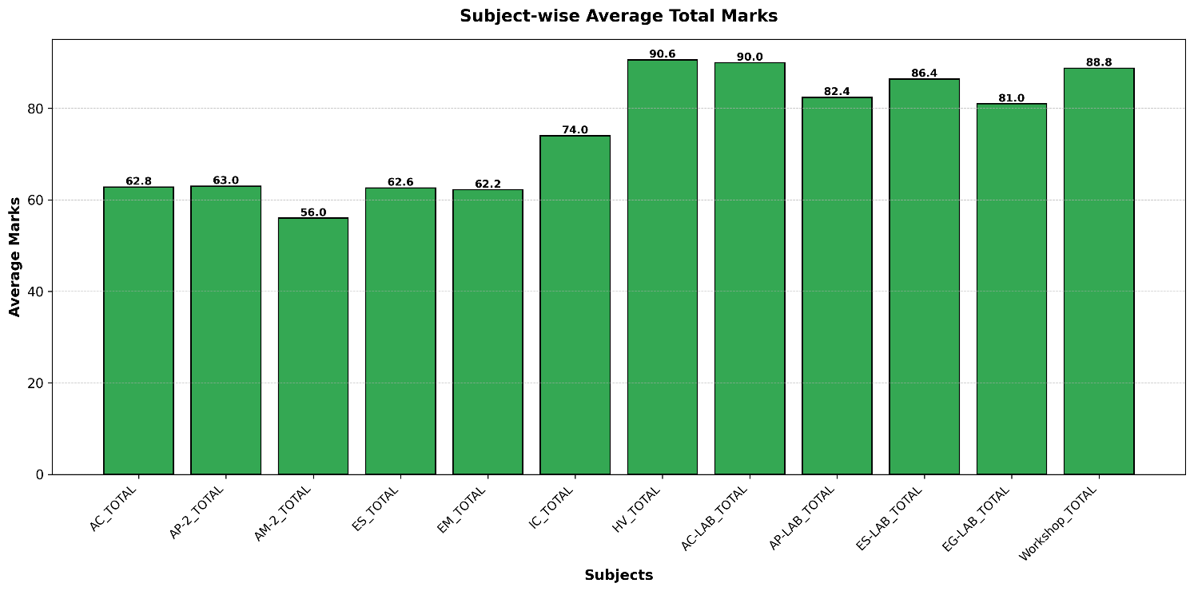

**Observation:**  
As seen in the graph, **AM-2_TOTAL** had the lowest average marks at **56.0**, making it the most challenging subject for the group. In contrast, **IC_TOTAL** and **HV_TOTAL** had the highest averages, indicating comparatively better group performance in these subjects

**4. Standard Deviation of Subject Marks:**  
The **standard deviation** of total marks was calculated for each subject to measure how much the students’ marks varied from the average. A higher standard deviation indicates more variation in marks among the students, while a lower value suggests consistent performance.

**Visualization:**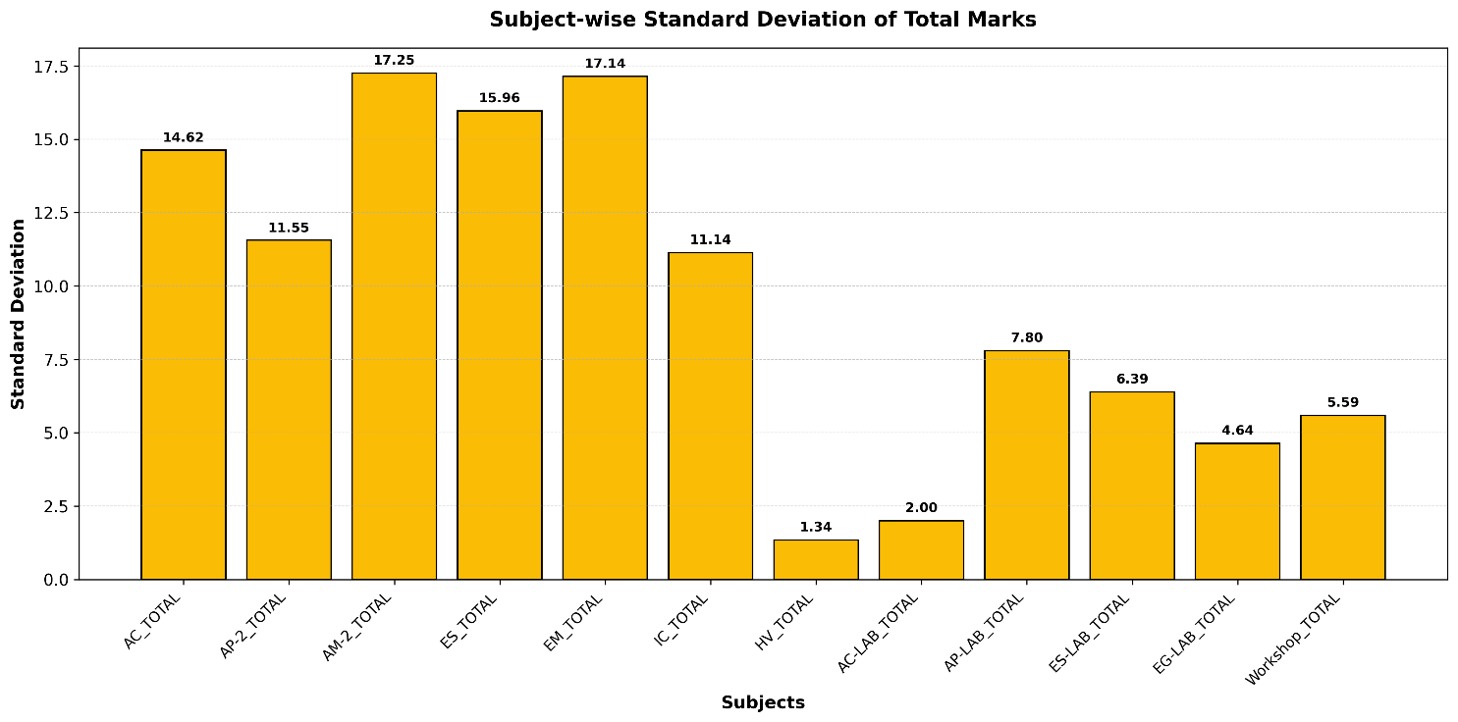

**Observation:**

The graph clearly shows that **AM-2_TOTAL** and **EM_TOTAL** had the highest standard deviations at **17.25** and **17.14** respectively, indicating these subjects had the widest range of scores in the group. On the other hand, **HV_TOTAL** had the lowest standard deviation of **1.34**, reflecting very consistent performance across all students in that subject.

**5. Internal vs External Average Comparison:**  
The average internal and external marks for each subject were compared to observe whether students performed better in internal assessments or external university exams.

**Visualization:**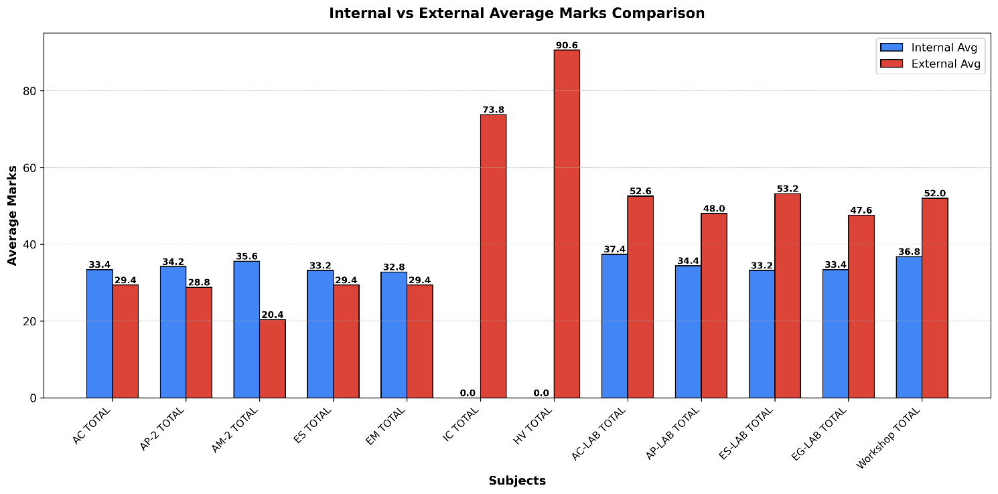

**Observation:**

From the graph, it’s evident that in most theory subjects like **AC_TOTAL**, **AP-2_TOTAL**, and **AM-2_TOTAL**, the average internal marks were slightly higher than external marks. However, in lab-based and practical subjects such as **AC-LAB_TOTAL**, **AP-LAB_TOTAL**, and **Workshop_TOTAL**, external exam averages were noticeably higher than internals. This pattern highlights that students performed more confidently in final lab exams compared to written assessments.

Interestingly, **IC_TOTAL** and **HV_TOTAL** show external marks only because these subjects didn’t have internal assessments.

**6. SGPA Distribution Analysis:**  
The group’s SGPA values were categorized into ranges (like 7.0–8.0, 8.0–9.0, etc.) to understand the overall grade distribution within the group.

**Visualization:**

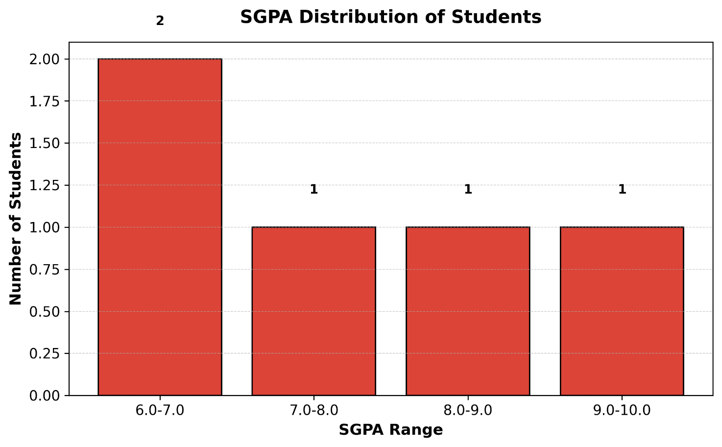

**Observation:**  
As per the graph, **2 students secured an SGPA between 6.0-7.0**, while **one student each** fell in the 7.0-8.0, 8.0-9.0, and 9.0-10.0 ranges. This distribution reflects a relatively balanced performance in the group, with most students scoring above 6.0 SGPA.

**Official Percentage vs Credit-Weighted Percentage**

Since different subjects carry different credit weights in IPU’s evaluation system, a **Credit-Weighted Percentage** was calculated and compared against the **Official Percentage** declared by the university.

**Formula Used:**

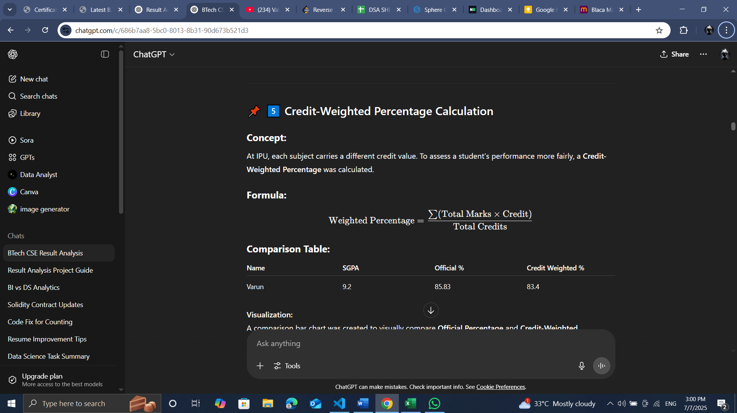

**Comparison Table:**

|  |  |  |  |
| --- | --- | --- | --- |
| **Name** | **SGPA** | **Official Percentage** | **Credit Weighted Percentage** |
| Varun | 9.2 | 85.83% | 83.40% |
| Deepul | 7.9 | 75.75% | 69.44% |
| Anish | 8.4 | 77.83% | 74.08% |
| Saransh | 6.3 | 69.00% | 61.44% |
| Vaibhav | 6.3 | 66.41% | 58.00% |

**Visualization:**

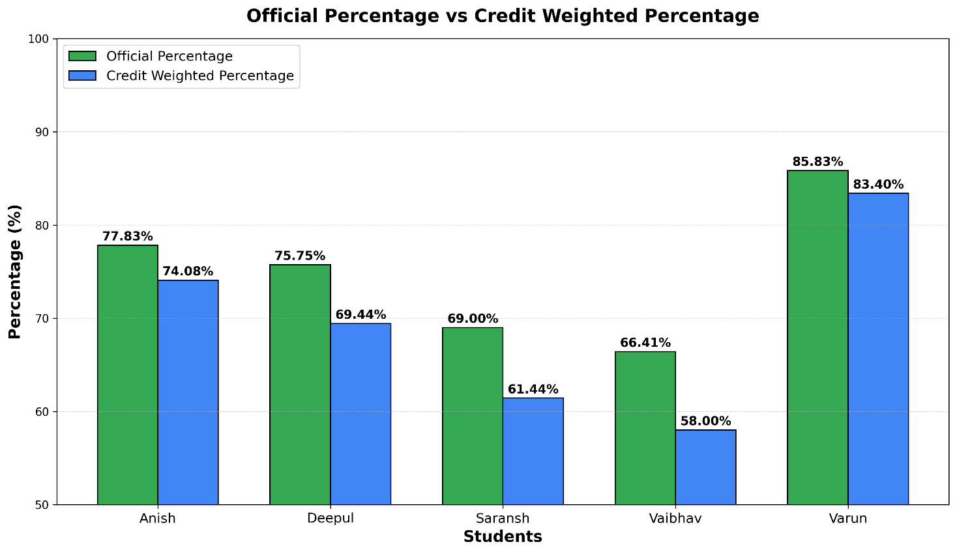

**Observation:**  
It’s evident from the graph that **the credit-weighted percentages were slightly lower than the official percentages** for every student. This happened because subjects with higher credits (which had relatively moderate scores) affected the weighted percentage more than lower credit subjects with higher marks.

For example, **Varun** maintained the highest score in both measures — but even for him, the weighted percentage dipped slightly compared to the official one.

**Observations & Inference**

These analyses provided useful insights about **subject difficulties**, **scoring patterns**, and **individual performances** within our small academic group.

**Key takeaways from the analysis:**

* **AM-2_TOTAL** emerged as the toughest subject for the group, with the lowest average score and one of the highest standard deviations, indicating both difficulty and inconsistency.
* **HV_TOTAL** was the subject where all students performed consistently well, as shown by the highest average and the lowest standard deviation.
* In most theory subjects, **internal marks were slightly higher than external marks**, reflecting better performance in class tests and assignments compared to the final university exam.
* Practical/lab-based subjects like **AC-LAB_TOTAL** and **Workshop_TOTAL** showed the opposite — external exam marks were higher than internal assessments.
* The **SGPA distribution** graph showed that while most students performed decently (with 2 in the 6.0-7.0 SGPA range), there were also higher scorers in the 8.0+ range, making the group’s overall performance quite balanced.
* Comparing **official percentages to credit-weighted percentages** revealed that students’ weighted percentages were slightly lower due to heavier credit subjects pulling down overall averages, especially if those scores weren’t proportionally high.

**Conclusion**

Through this small-scale result analysis project, we were able to **understand academic performance patterns within our friend group** using simple data analysis techniques.

By manually collecting marks from the IPU rank list and organizing them into a structured dataset, we explored trends like **which subjects were comparatively tough or easy, how internal and external marks differed, and how SGPA varied across students**.

The analysis showed that **data-driven evaluations can reveal insights not immediately visible from marksheets alone** — like which subjects had inconsistent scoring, or how credit weightage can influence overall percentages.

Using **Python libraries like Pandas, NumPy, Matplotlib, and Seaborn**, we created meaningful graphs and comparisons that made these findings easier to interpret.

Overall, this project helped us realise the importance of **visualizing academic data** for fair performance reviews and identifying improvement areas — something that could be scaled for a larger student batch too.